**Experiment 3**

**Aim:** Design a Smartphone controlled system to control light.

**Apparatus:** Breadboard, Arduino, Resistances (470 ohm), Jumper wires, Bluetooth module, LED.

**Block Diagram:**

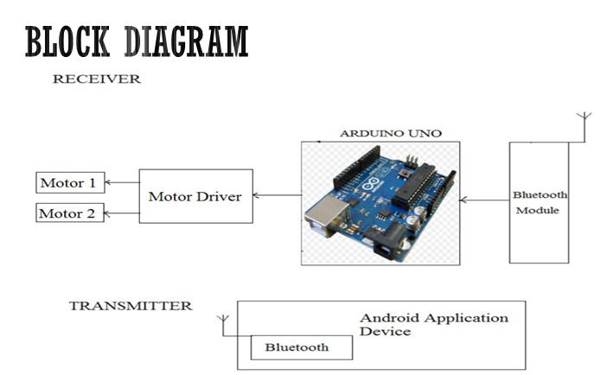

**Theory:**

1. Concept Used:
2. In Arduino, digital pins provide input as well as output but analog pins only provide input.
3. Transmitter pin of Bluetooth is connected to receiver pin of Arduino.
4. Receiver pin of Bluetooth is connected to transmitter pin of Arduino.
5. Current flows from anode to cathode and not in reverse direction through LEDs.
6. Learning & Observations:
7. Learn about different parts of Arduino and how to use them.
8. Arduino will pass signal to LED when it receives signal from Bluetooth.
9. LED may be damaged if we do not use resistance.
10. Bluetooth will receive signals from app and pass on to Arduino.

**Problems and Troubleshooting:**

1. Connecting the Bluetooth module with Bluetooth app. Trying two to three times problem was solved.
2. Bluetooth was not working properly. Problem was solved on checking connections. Some connections were loose.

**Precautions:**

1. Connections should be made carefully and clearly.
2. Using “if-else” carefully.
3. Transmitter and receiver pin of Bluetooth should be connected to receiver and transmitter pin of Arduino respectively.
4. Use right commands for serial monitor to store, show readings.

**Learning Outcomes:**

1. Using Arduino and defining output pins.
2. Using void setup and void loop.
3. Bluetooth should be provided with 5V supply to work.
4. Arduino works on the basis of signal passed by Bluetooth module.

**Result:** Smartphone controlled light system was verified after running the program.